MP8000
SETTING UP THE PLC PROJECT
ROCKWELL PLC

- First open the Studio 5000 software by double-clicking the shortcut icon on the desktop
- Select “New Project” in the “Create” menu
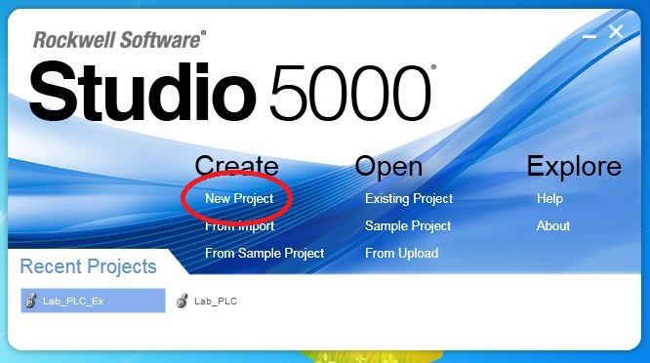
- Select the correct PLC controller type from the list, give the project a name, and select a location where the project will be stored
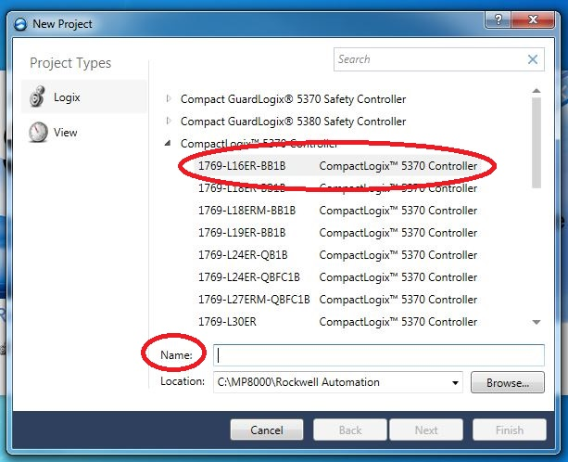

- Select the revision of the controller code, the number of “Expansion I/O” modules, and the level of “Security Authority” desired
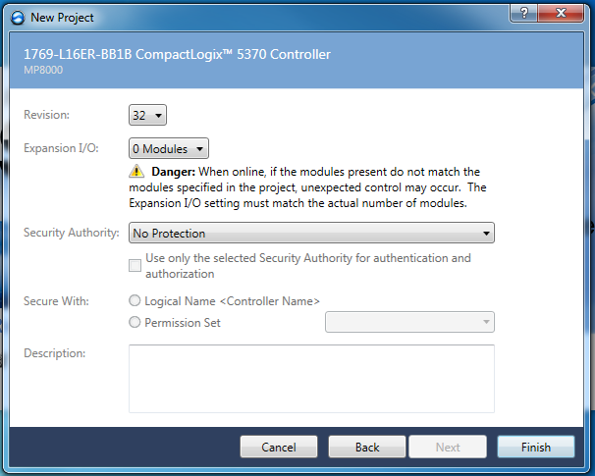
- Click the “Finish” button
- The newly created project will open in the Studio 5000 environment
- Add the MP8000 EDS file to the Studio 5000 Logix Designer project
- From the TOOLS menu, select EDS Hardware Installation Tool
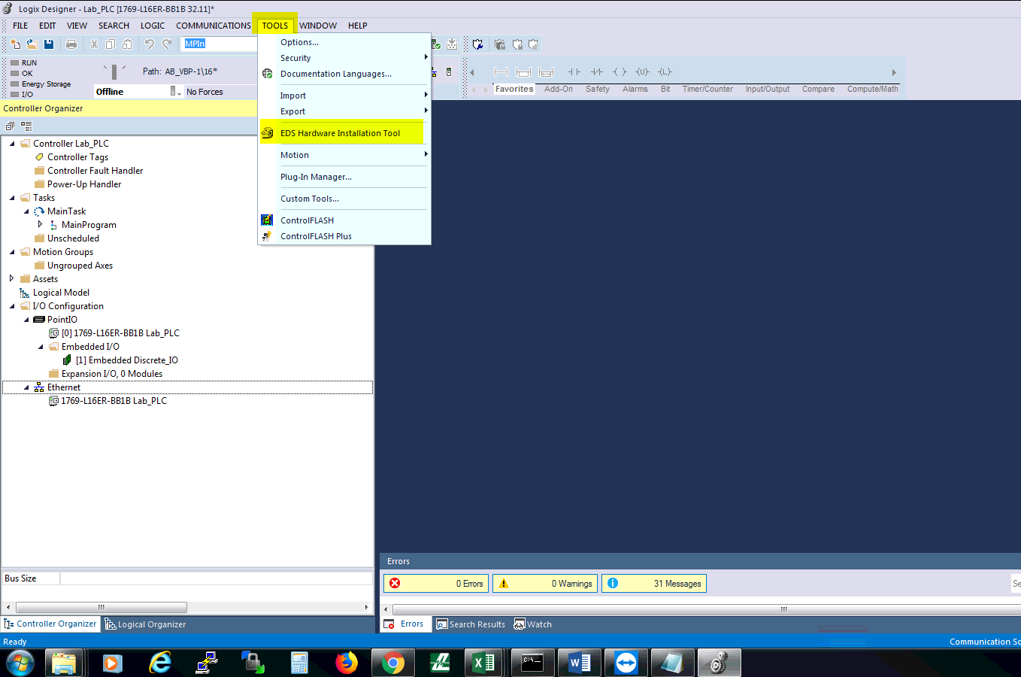
- The Rockwell Automation EDS Wizard will open
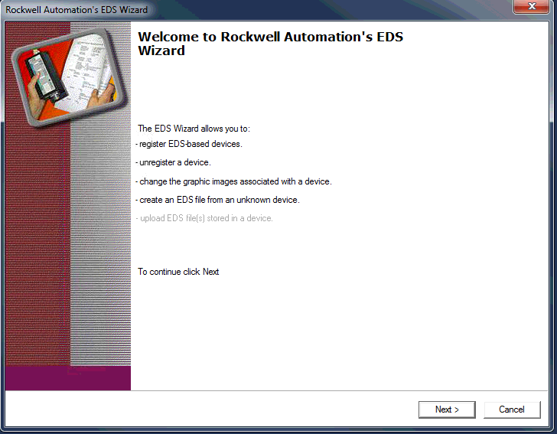
- Click the “Next” button
- Select the radial button next to “Register an EDS File”
- Click the “Next” button
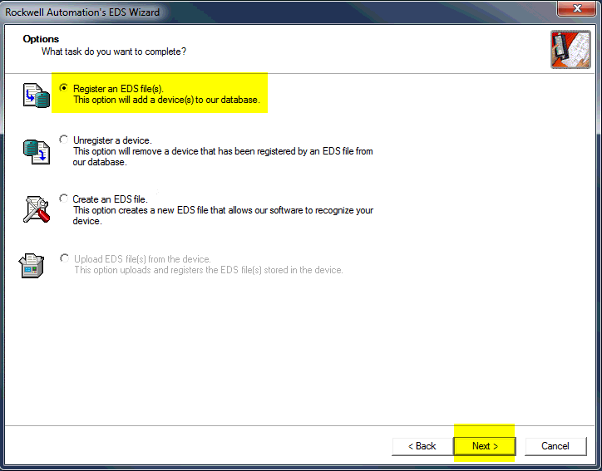
- On the next screen, click the radial button next to “Register a single file”
- Use the “Browse” button to point the wizard to the location of the MP8000.eds file
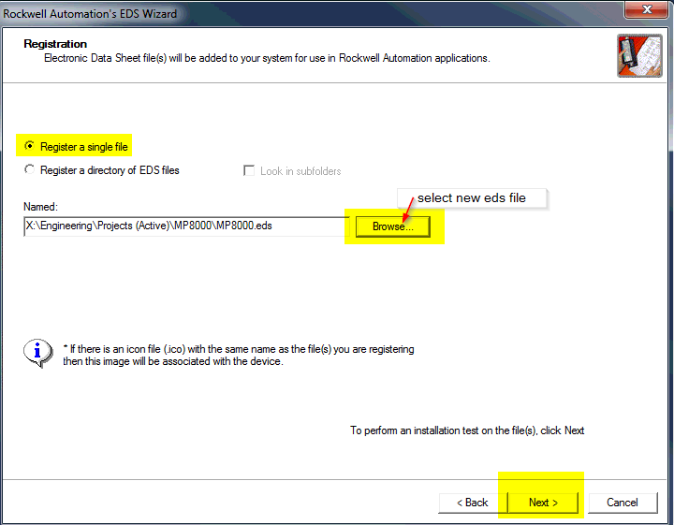
- Click the “Next button” to begin an installation test of the EDS file
- The wizard will display the results of the installation test of the EDS file
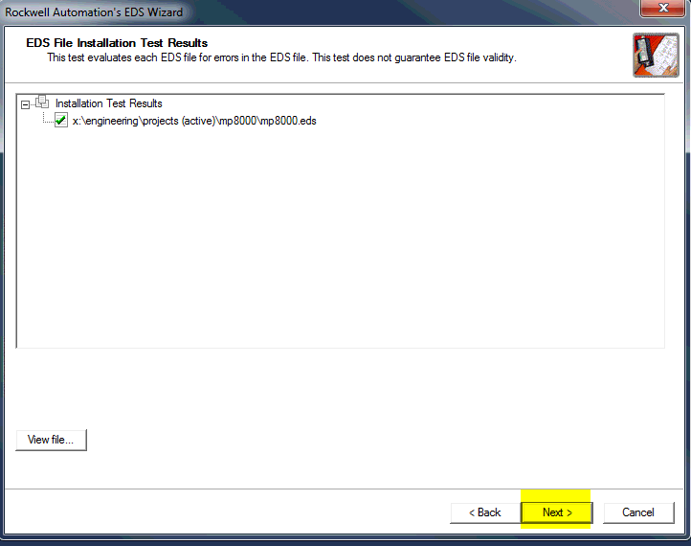

- Click the “Next” button
- Now the wizard will allow you to change the icon shown for the EDS file
- Click the “Change icon…” button
  - If the Littelfuse icon is already shown, click the “Next” button and skip to step 22
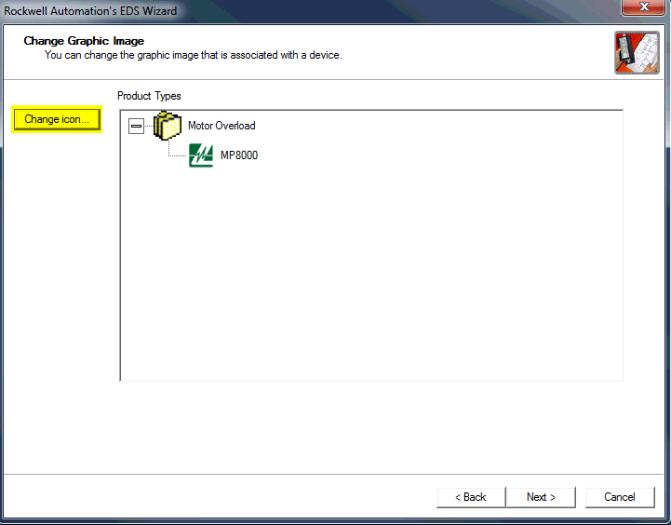
- The “Change Icon” screen will appear
- Click on the “Browse” button on navigate to the location of the LittelfuseIcon.ico file
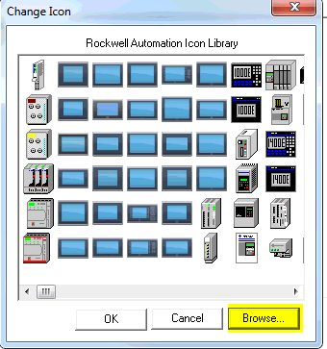
- After you click the “Open” button, the wizard will show the “Final Task Summary” screen
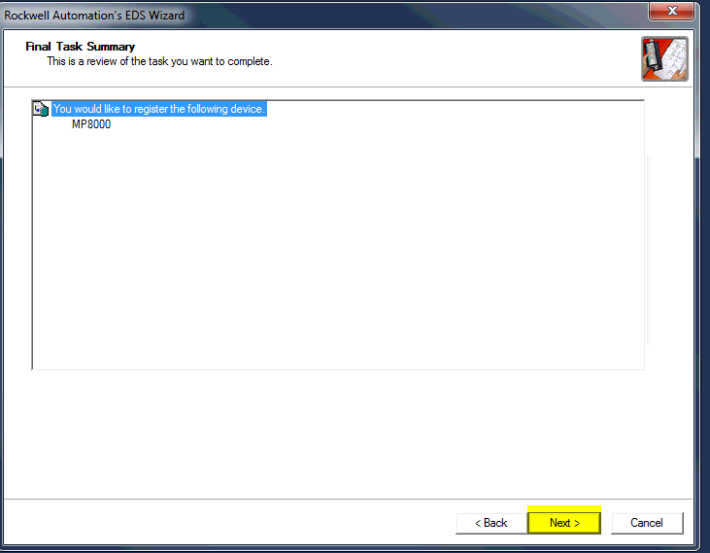
- Click the “Next” button if everything is proper and correct
- Click the “Finish” button to complete the EDS file installation
- To begin working with the newly registered EDS file, right-click I/O Configuration->Ethernet in the tree-view of the left pane of the Logix Designer window and select “New Module…”
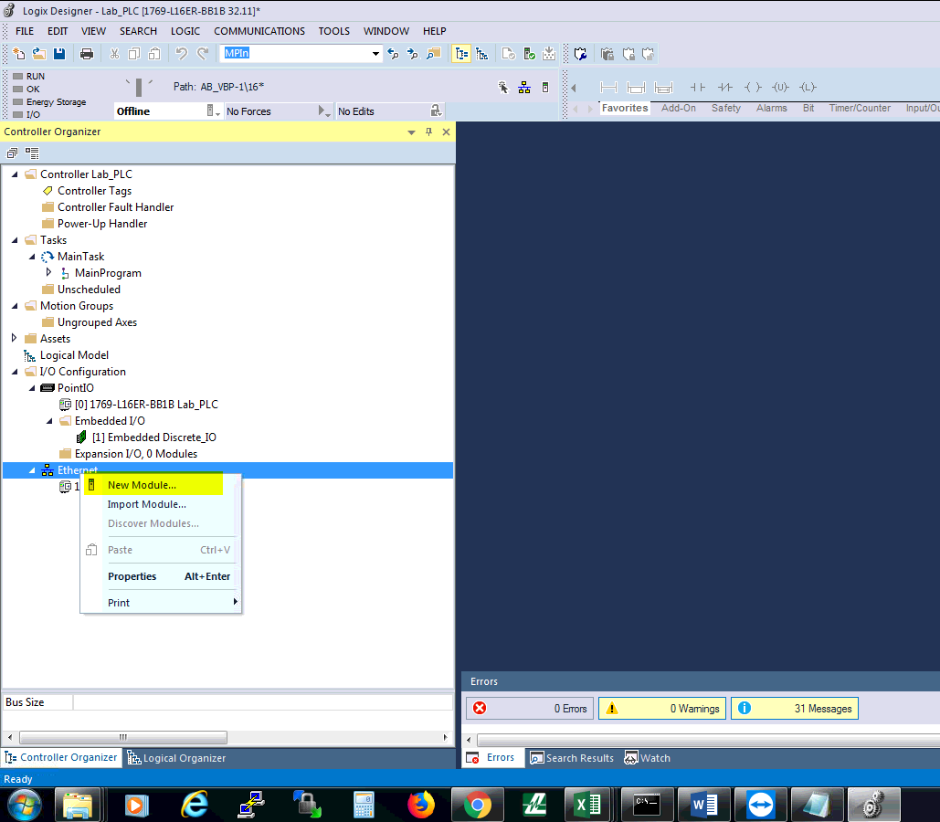
- The “Select Module Type” window will open
- In the “Enter Search Text for Module Type…” field, enter the search text “MP8000”
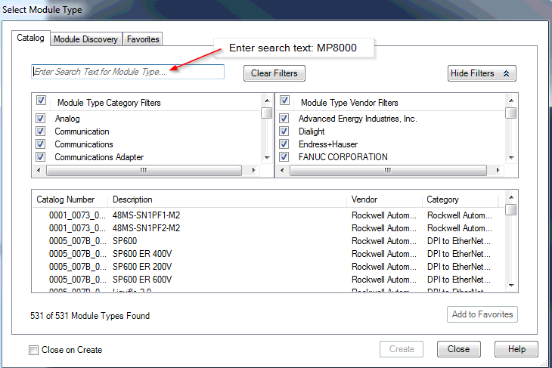
- Select the MP8000 catalog entry, then press the “Create” button
  - The correct entry will have the Product Code of 8003 (hex 1F43) shown in its catalog number
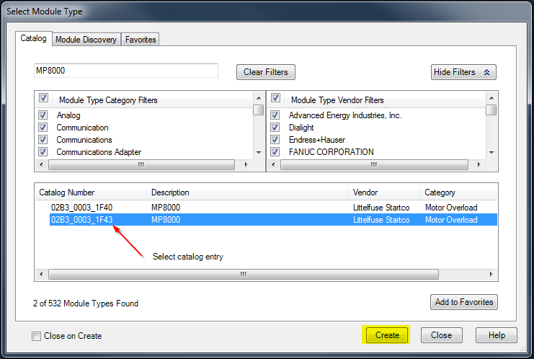
- Add a “Name” field, enter the static IP address of the MP8000, and press the “Change…” button
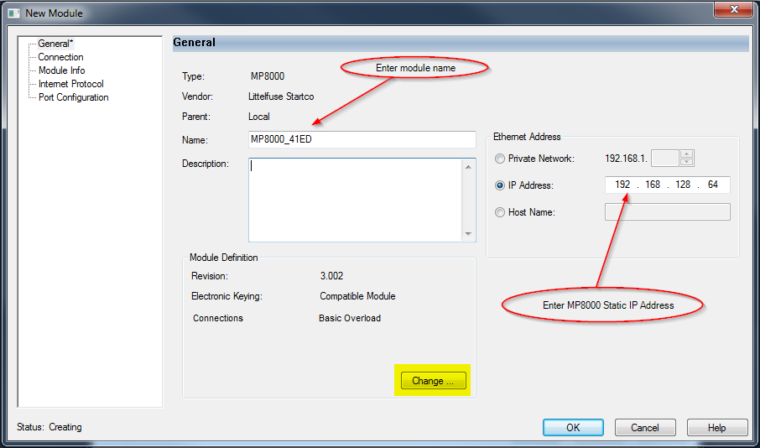
- Use the drop-down menu to select the type of “Electronic Keying” you would like to use
  - Exact Match, Compatible Module, or Disable Keying
- Click on the “Basic Overload” selection to reveal the drop-down menu to determine connection
  - Select “RTS+Fault and Advanced Config”
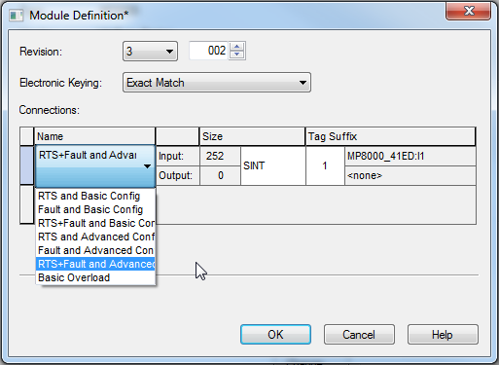
- Click the “OK” button
- Logix Designer will ask you if you would like to “Change module definition”, select “Yes”
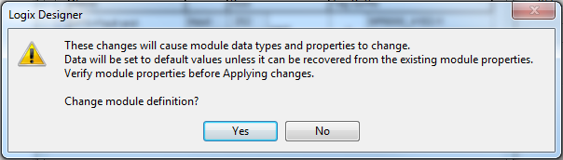
- Ensure that the correct Electronic Keying and Connections types are displayed in the “New Module” window, then press the “OK” button
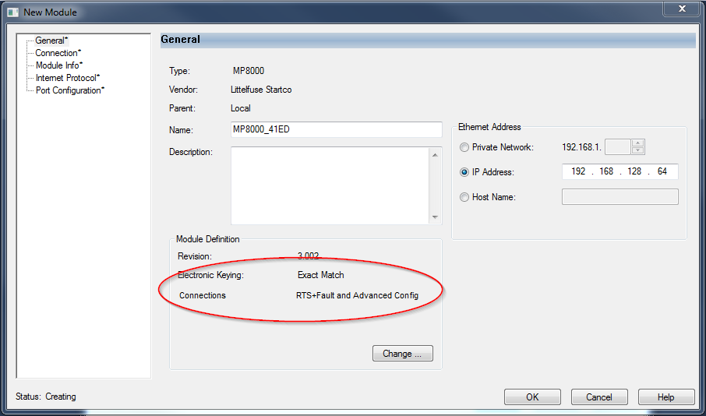
- Close the “Select Module Type” window
- The newly created module will now appear in the tree-view panel in the I/O Configuration -> Ethernet of the project
- In the tree-view panel, right-click “Assets -> Data Types -> User-Defined” and select “Import Data Type…”
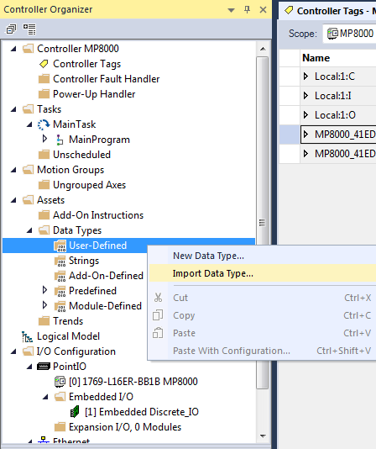
- In the “Import Data Type” window, navigate to the location of a previously created Data-type
- Highlight the desired .L5X file and then click the “Open” button
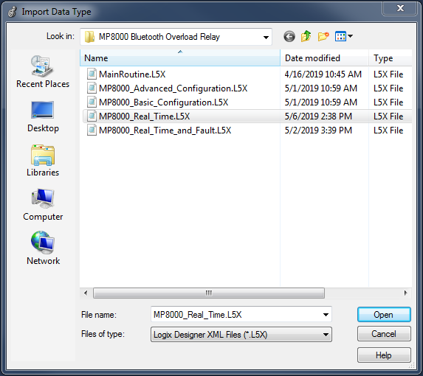
- The “Import Configuration” window will open, just press the “OK” button
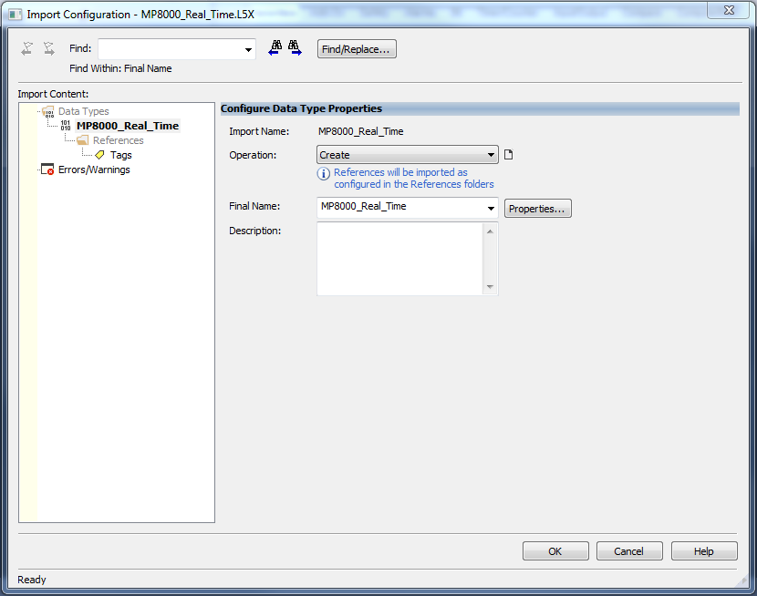
- In the tree-view panel, right click “Controller Tags” and select “New Tag…”
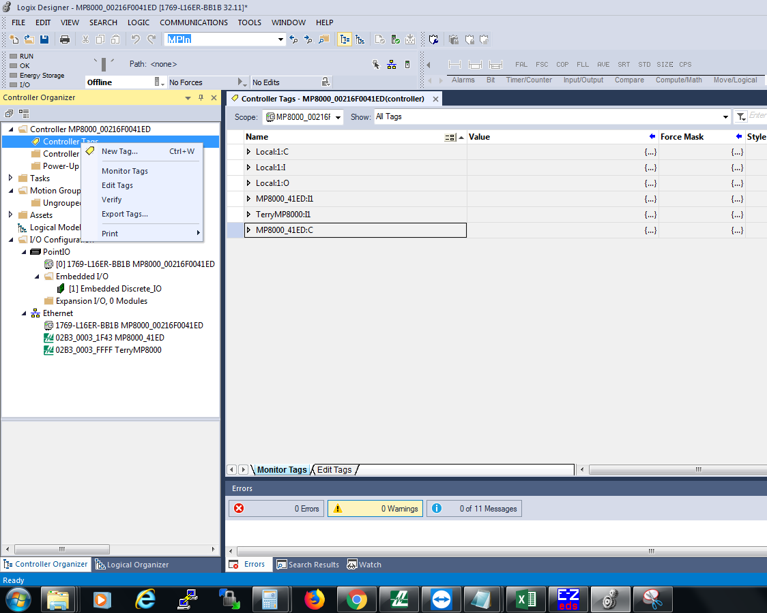
- The “New Tag” window will open
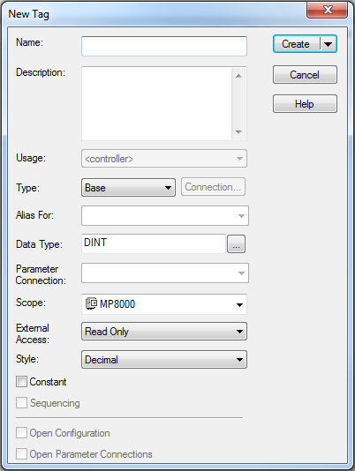
- In the “Name” field, give the tag a unique identifier
- In the “Data Type” field, click the “…” button and scroll down in the list until you find the correct data type
- Click the “Create” button
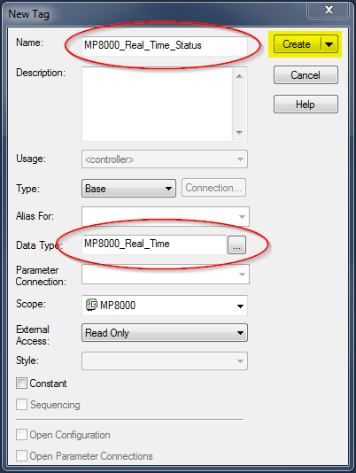
- In the tree-view panel, expand Tasks -> Main Task -> Main Program -> Main Routine
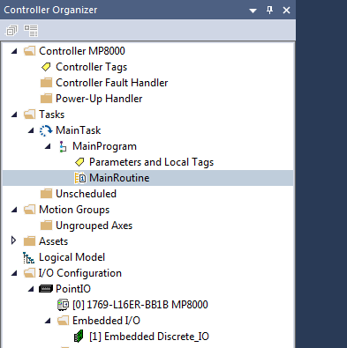
- Above the “Main Routine” tab, use the “right arrow” to scroll until you see “File/Misc.”, then click on “CPS”
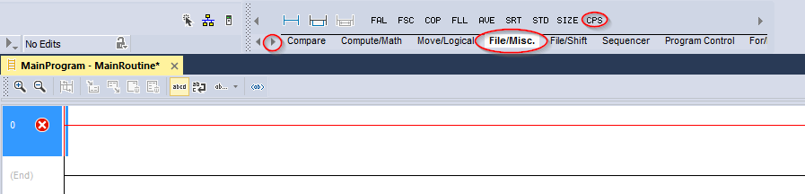
- The CPS instruction will appear in the first rung of the Main Routine ladder logic
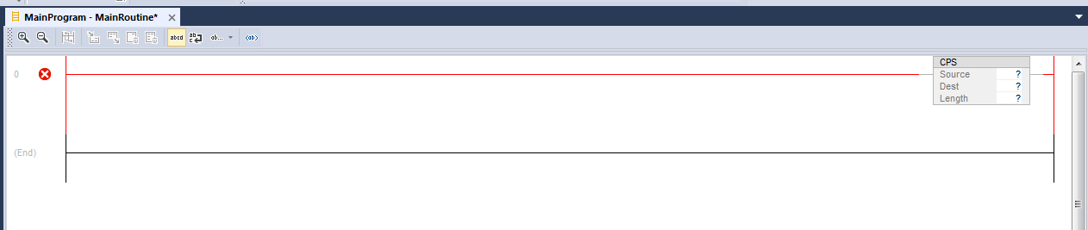
- Double-clicking the “?” next to “Source” will allow you to tell the routine where the data is coming from
  - In the case of REAL TIME data, the source should always be pointed at {MODULENAME:I1.Data[0]}
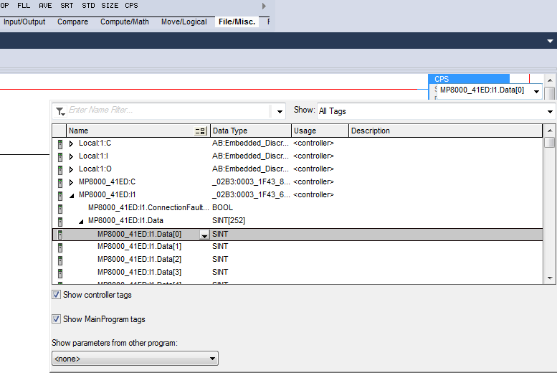
- Double-clicking the “?” next to “Dest” will allow you to tell the routine where the data will be parsed to
  - This will be the Controller Tag created in steps 41-45
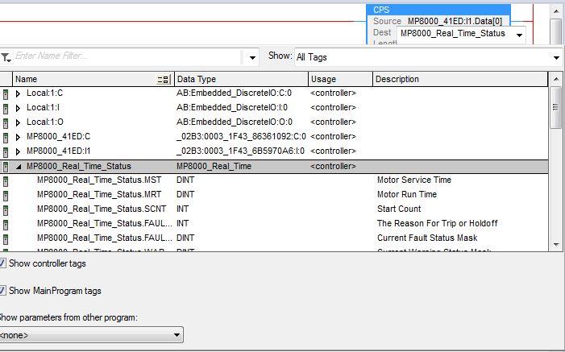
- Single click the “?” next to “Length” and type a 1 in the box
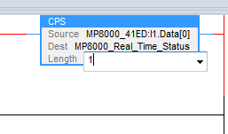
- In the main tool bar, open COMMUNICATIONS -> “Who Active”
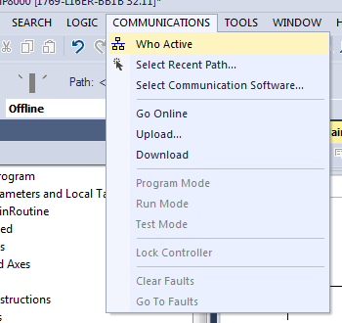
- The “Who Active” window will open
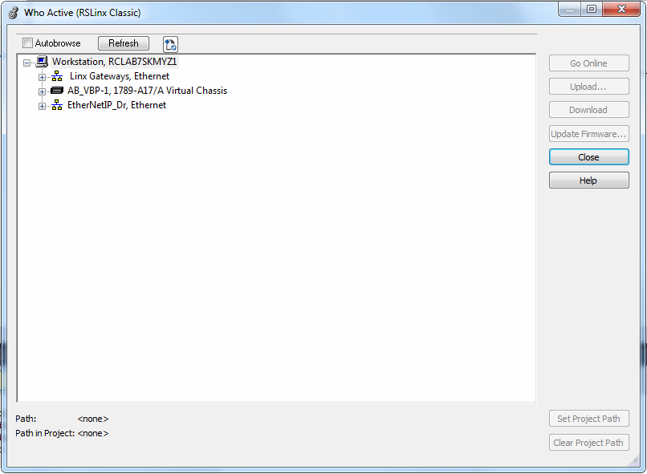
- As all of our communications in the lab setting are to be done via the Ethernet connection, expand the “EtherNetIP_Dr,Ethernet” selection in the “Who Active” window
- Highlight the entry for the connected PLC
- Click on the “Download” button
  - If the “Download” button remains greyed-out, manually remove all of the links below “EtherNetIP_Dr, Ethernet” and then press the “Refresh” button at the top of the window
  - Also make sure the wifi of the laptop is turned off
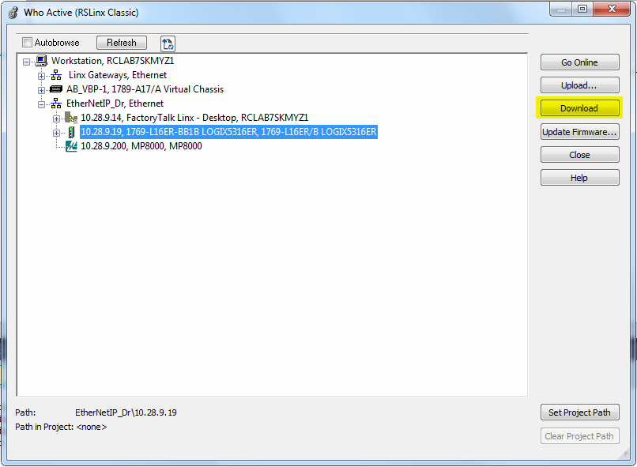
- The “Download” window will appear, click the “Download” button
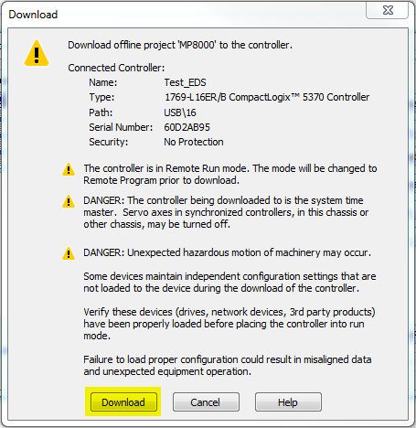
- The PLC will switch to “Rem Prog” mode after the download has occurred
- The download will cause the default configuration values stored in the .eds file to be set on the connected MP8000
  - Make sure to correct the Configuration Values prior to beginning to use the MP8000
  - If the CNFG values are anything but 0x6001, they are incorrect for a default setting
- Controller status must be set to “Rem Run” for communication to take place
  - If no communication occurs, but no module errors shown, verify this setting
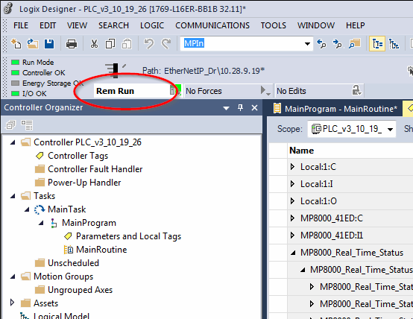
- If you open a previously created project, the communication path will have to be re-established using the same steps described in process steps 52-57
- Real time data from the MP8000 that is shown in the Logix Designer environment is displayed as the raw data from the unit. This data can be interpreted as described by the following table.
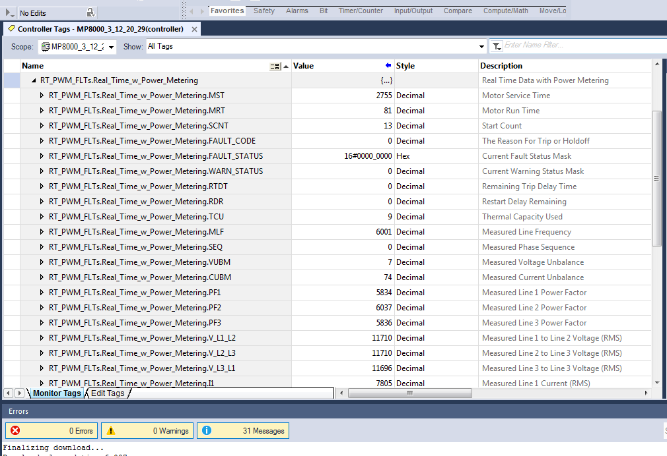
Parameter Name | Description | Interpret the Data
MST | Motor Service Time | A count shown in seconds
MRT | Motor Run Time | A count shown in seconds
SCNT | Start Count | A count
FAULT_CODE | The Reason For Trip or Holdoff | Fault codes in table below
FAULT_STATUS | Current Fault Status Mask | Fault status masks in table below
WARN_STATUS | Current Warning Status Mask | Warning status masks in table below
RTDT | Remaining Trip Delay Time | A count shown in seconds
RDR | Restart Delay Remaining | A count shown in seconds
TCU | Thermal Capacity Used | Divide by 100 to show actual value
MLF | Measured Line Frequency | Divide by 100 to show actual value
SEQ | Measured Phase Sequence | 0 – ABC ; 1 – ACB
VUBM | Measured Voltage Unbalance | Divide by 100 to show actual value
CUBM | Measured Current Unbalance | Divide by 100 to show actual value
PF1 | Measured Line 1 Power Factor | Divide value by 16383 (0x3FFF)
PF2 | Measured Line 2 Power Factor | Divide value by 16383 (0x3FFF)
PF3 | Measured Line 3 Power Factor | Divide value by 16383 (0x3FFF)
V_L1_L2 | Measured L1 to L2 Voltage (RMS) | Divide by 100 to show actual value
V_L2_L3 | Measured L2 to L3 Voltage (RMS) | Divide by 100 to show actual value
V_L3_L1 | Measured L3 to L1 Voltage (RMS) | Divide by 100 to show actual value
I1 | Measured Line 1 Current (RMS) | Divide by 100 to show actual value
I2 | Measured Line 2 Current (RMS) | Divide by 100 to show actual value
I3 | Measured Line 3 Current (RMS) | Divide by 100 to show actual value
P1 | Measured Line 1 Power | Divide by 1000 to show actual value
P2 | Measured Line 2 Power | Divide by 1000 to show actual value
P3 | Measured Line 3 Power | Divide by 1000 to show actual value
IGF | Ground Fault Current | Divide by 100 to show actual value
PTC | Positive Temperature Coefficient | A raw number used by FW
MOTORR | Motor Relay State | 0 – Relaxed ; 1 – Energized
AUXR | Auxiliary Relay State | 0 – Relaxed ; 1 – Energized
KW | Instantaneous Real Power Measurement (kW) | Shown as Watts
VAR | Instantaneous Reactive Power Measurement (kVAR) | Shown as VARs
INPUT | Input I/O States | 0-None; 1-I0 high; 2-I1 high; 3-both
MKW | Metered Real Power Accumulation (kWhr) | Shown as Whrs, divide by 1000
MVAR | Metered Reactive Power Accumulation (kVARhr) | Shown as VARhrs, divide by 1000
FW_REV | Firmware Revision | A representation of the FW revision
PC | Product Code | The Product Code of the unit

Fault Condition | Code (Decimal) | Status (Hex)
No fault or warning condition | 0 | 0x00000000
Tripped on overcurrent | 1 | 0x00000001
Tripped on undercurrent | 2 | 0x00000002
Tripped on current unbalance | 3 | 0x00000004
Tripped on current single-phasing | 4 | 0x00000008
Tripped on contactor failure | 5 | 0x00000010
Tripped on ground fault | 6 | 0x00000020
Tripped on High Power Fault | 7 | 0x00000040
Tripped on low power fault | 8 | 0x00000080
Low Control Voltage Fault | 9 | 0x00000100
Trip or holdoff due to PTC fault | 10 | 0x00000200
Tripped triggered from remote source | 11 | 0x00000400
Tripped on Linear Overcurrent | 12 | 0x00000800
Tripped Motor Stall | 13 | 0x00001000
Active Restart Delay Field Bit 0 | N/A | 0x00010000
Active Restart Delay Field Bit 1 | N/A | 0x00020000
Active Restart Delay Field Bit 2 | N/A | 0x00040000
Tripped on PTC Short | 14 | 0x00200000
Tripped on PTC Open | 15 | 0x00400000
Manual Restart Required | N/A | 0x00080000
MP8000 FMEA Fault | 4097 | 0x01000000
Fault Code and Status Table

Warning Condition | Code (Decimal) | Status (Hex)
No Warning Condition Present | N/A | 0x00000000
Overcurrent Detected | N/A | 0x00000001
Undercurrent Detected | N/A | 0x00000002
Current Unbalance Detected | N/A | 0x00000004
Current Single Phasing Detected | N/A | 0x00000008
Contactor Failure Detected | N/A | 0x00000010
Ground Fault Detected | N/A | 0x00000020
High Power Detected | N/A | 0x00000040
Low Power Detected | N/A | 0x00000080
Low Control Voltage Detected | N/A | 0x00000100
PTC Holdoff | N/A | 0x00000200
Linear Overcurrent Detected | N/A | 0x00000800
Motor Stall Detected | N/A | 0x00001000
Low voltage Holdoff | 100 | 0x00010000
High Voltage Holdoff | 101 | 0x00020000
Voltage Unbalanced Holdoff | 102 | 0x00040000
Phase Sequence Holdoff | 103 | 0x00080000
Undefined Holdoff | N/A | 0x00100000
Ground Fault Alarm | 16 | 0x00800000
Warning Code and Status Table

